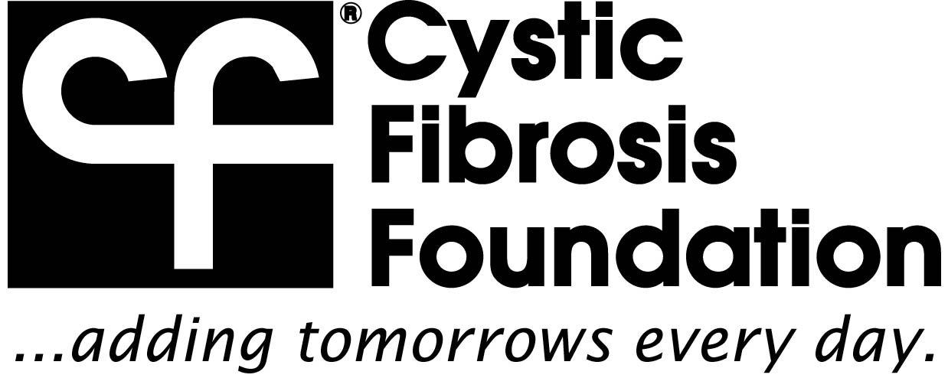
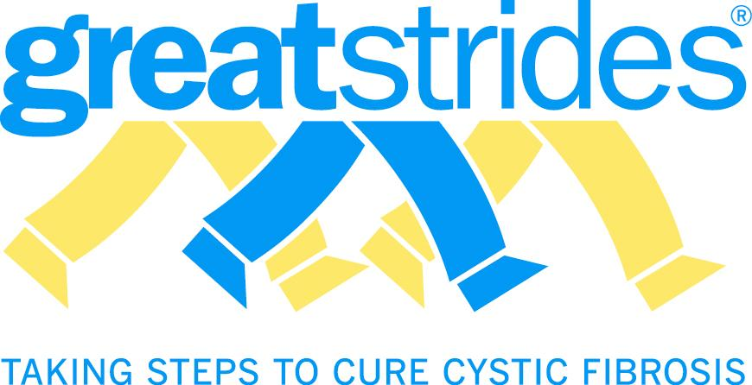

Cystic Fibrosis Foundation, Delaware Valley Chapter
2004 Sproul Road, Suite 208
Broomall, PA, 19008
Federal Tax Identification #: 13-1930701

To Whom It May Concern:

Please be informed that Jerry Kuhlman, Troy Bowen, Jennifer O’Mahoney and their family and friends are soliciting for the 23rd Annual Summer Solstice being held in Chester County on Saturday, June 7th, 2014 in which all proceeds will benefit the Cystic Fibrosis Foundation. We are asking for your help by donating items or gift certificates that can be used for auction or sale during the event. Any funds that you donate will help in our effort to raise monies for research to find a cure for Cystic Fibrosis, and help children with this progressive and fatal disease live a healthier life.

Cystic fibrosis is a life-threatening genetic disease that affects the lungs and digestive systems of approximately 30,000 children and adults in the United States (70,000 worldwide). One in 31 Americans (more than 10 million people) is an unknowing, symptom-less carrier of the defective CF gene. CF causes the body to produce abnormally thick, sticky mucus. This abnormal mucus leads to chronic and life-threatening lung infections and impairs digestion. Although the outlook for a child born with CF today has improved tremendously over the years, it is still not good enough.

Summer Solstice is a fun-filled, family event, held on a beautiful 300-acre farm in Chester County, and includes multiple performances by local bands from the tri-state area. We are proud to announce that Summer Solstice has chosen the Cystic Fibrosis Foundation as the sole beneficiary for a second year, and we are honored to be a part of this event.

The CF Foundation has frequently been cited as one of the most effective and efficient organizations of its kind. It has received a four-star rating for sound fiscal management from Charity Navigator, the largest independent charity evaluator in the United States, and is an accredited charity of the Better Business Bureau’s Wise Giving Alliance. Nearly 90 cents of every dollar raised is invested in cystic fibrosis research, education, and care programs.

Please take a moment to fill out the enclosed donation form and help make CF stand for Cure Found.

Thank you in advance for your support. For your records, the CF Foundation’s Federal Tax Identification number is 13-1930701. Please contact Robin Clarke with any questions at (610) 325-6001 or by email at rclarke@cff.org

Thank you for your time and consideration.

Sincerely,
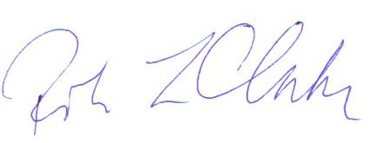

Robin Clarke
Director of Special Events

